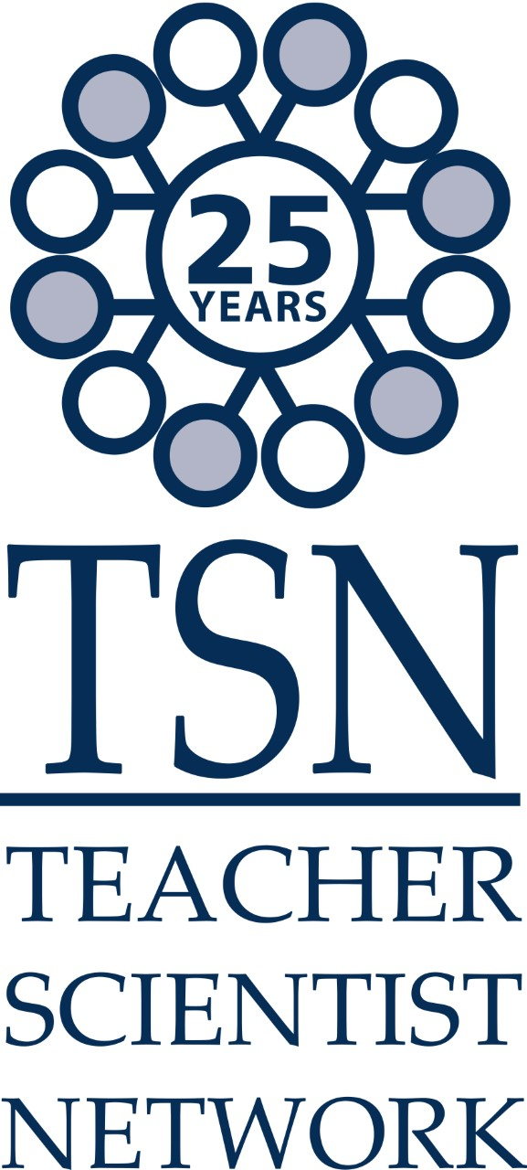
PRESS RELEASE

DATE: Friday 18th October 2019

NO EMBARGO

Be careful who you sit next to at a Science Dinner!

An established local science education charity, the Teacher Scientist Network¹ is reaping the benefits of last year’s Dinner with a Difference event held during Norwich Science Festival² and this year’s guests will get to meet a new member of the team at this year’s tasty offering for the Festival in less than 1 week.

In 2016, at a festival networking event Dr. Phil Smith (coordinator of TSN) met Sarah Daniels the founder of the Red Cat Partnership and they hatched a plan for a novel science-themed fundraising event to be trialled during Norwich Science Festival. Two years later the event ‘sold-out’ and was featured in the EDP’s ‘Top 5 things not to miss at Norwich Science Festival’ raising enough money to purchase a brand new skeleton to add to TSN’s highly acclaimed Kit Club, that loans science resources to local schools.

Dinner with a Difference³ offers diners a high-quality 3 course meal that is interspersed with food science and science entertainment. The meal is prepared by chef Scott Taylor who uses science extensively throughout his cooking and gives his time freely to support the event. The event takes place in Red Cat’s meeting rooms that are transformed into a pop-up restaurant for the evening. Dr Phil and fellow scientist Dr. Duncan Gaskin cover the science, a real team effort.

Sarah Daniels, founder of the Red Cat Partnership commented “We ae very proud to have hosted the Dinner with a Difference events at No.8 Thorpe Road, and being able to donate Alex the Skeleton from the proceeds of the Dinner. The Dinners have been very well received, and we look forward to building on this for this years’ programme with a whole day of events! Science is around us every day, and Food Safety is changing rapidly, so it’s important for us, to challenge ourselves, learn new things whilst having some fun; hence we are excited to continue our support for the festival and particularly the great work of the Teacher Scientist Network”

“We all love the event, and to have a tangible end-product that enhances science teaching across Norfolk is the icing on the cake” Dr. Phil added, “our current skeletons are showing their age, after countless trips to schools usually in the passenger seat of a teacher’s car and ourselves and Norfolk teachers and school children are most grateful to everyone who supports this event.”

With this year’s festival offerings less than a week away, the team are busy preparing for this year’s events which sees them expanding their offer to include Tea with a Twist³, supported by Tim Kinnaird from Macarons and More. We wait to see what these events will add to the Kit Club!

PHOTO CREDITS:

DSC_0624.JPG: Alex the new TSN Skeleton pictured with Dr Phil Smith, MBE (TSN Coordinator) and Sarah Daniels (Director, Red Cat Partnership)

Notes for editors
- The Teacher Scientist Network is a 25 year old science education charity, hosted by the John Innes Centre. Details of their Kit Club and other activities can be found on their website, www.tsn.org.uk/KitClub.htm
- Norwich Science Festival. Celebrate the wonderful world of experiments, discoveries, exploration and innovation at Norwich Science Festival this October. Enjoy inspirational exhibitions, hands-on family activities, inspiring celebrity talks and sensational shows at The Forum, and at other venues around the city. This is a festival for all age groups and all levels of knowledge. The 2019 Festival patrons include Lizzie Daly –– TV presenter and wildlife biologist, Mark Thompson – astronomer, broadcaster and author, and Ben Garrod – evolutionary biologist and great ape conservationist. The 2019 headline sponsor is Anglian Water, with additional sponsorship from Norwich Accountancy Services, University Technical College Norfolk, Vattenfall, Briar Chemicals, Fitness Space, Veolia, Roarr! Dinosaur Adventure, KLM UK Engineering and EIRA. Explore the Norwich Science Festival website for the full programme http://norwichsciencefestival.co.uk and follow Norwich Science Festival on Twitter and Facebook.
- The team are offering 2 food-themed science events this year on Thursday 26th October, Tea with a Twist (2.30 – 4.30pm, https://norwichsciencefestival.co.uk/events/tea-with-a-twist/ ) and Dinner with a Difference (from 6.30pm, https://norwichsciencefestival.co.uk/events/dinner-with-a-difference-3/ ). For bookings, contact the Red Cat Partnership directly on 01603 473732, Email: sarah@redcatpartnership.co.uk

< ENDS >

The Teacher Scientist Network is a company limited by guarantee. Chairman: Prof. Paul Nicholson
Registered in England No.4556366. Registered Charity No. 1096208 Coordinator: Dr. Philip H. Smith, MBE

Registered office: John Innes Centre, Colney Lane, Norwich, NR4 7UH email: phil.smith@nbi.ac.uk
Tel.: +44(0)1603 450304 Fax: +44(0)1603 450045 Internet: www.tsn.org.uk

